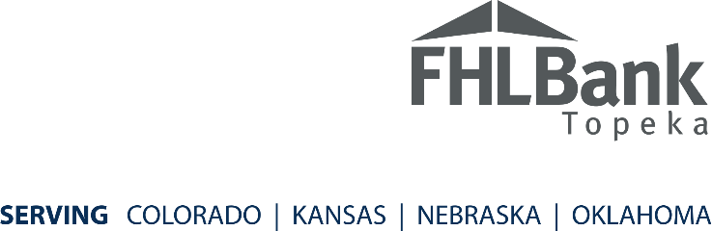

Please feel free to copy and paste the information below into your own press release template.
FOR IMMEDIATE RELEASE
DATE:
CONTACT:
PHONE: Test
EMAIL:
TestTest
Institution Name receives $500 for Nonprofit Cause
Institution Name, City, was awarded $500 through FHLBank Topeka’s recent #500forGood initiative. The initiative asked FHLBank member financial institutions to consider how they would use $500 to fill a need in their community. Institution Name submitted the request on behalf of a project for [enter project details].
Institution Name is one of 50 FHLBank member projects recently awarded funds to help with a community initiative. When the program began in 2018, eight recipients were selected. Because of the passion of FHLBank members and their employees across Colorado, Kansas, Nebraska and Oklahoma, contributions have grown to help even more community projects.
About Institution Name:
Insert boilerplate information.
About FHLBank Topeka:
FHLBank Topeka is one of 11 Federal Home Loan Banks that accesses the capital markets to provide liquidity and funding for its members. With $80 billion in assets and more than $4 billion in capital, FHLBank Topeka is a strong, reliable source of liquidity for its 655 member financial institutions in Colorado, Kansas, Nebraska and Oklahoma.

###

